

**Restful Services Testing Using Postman rest client**

**Ver 1.0**

**Create By: Vrunda Raghushe Date: 11 Dec 2016**

**Reviewed By: Ketki Chandrayan Date: 12 Dec 2016**

Table of Contents

1. Document History 3

2. What is Postman? 3

3. Setup – Installing Postman Native client and Chrome app 3

4. How to test Restful Service and get the Payload using Postman Rest Client? 4

4.1 Steps: 4

i. Install Postman rest client and access it through google chrome app 4

ii. Test restful service to get Payload 4

iii. Get request URL 4

iv. Test the Service 5

5. Appendix 5

5.1 References 5

# Document History

|  |  |  |  |  |  |
| --- | --- | --- | --- | --- | --- |
| **Sr. No** | **Version** | **Modifications** | **Date** | **Updated By** | **Updates** |
| 1 | 1.0 | Documents created | 10 Dec 2016 | Vrunda Raghushe | First version of document created |
|  |  |  |  |  |  |

# What is Postman?

Postman helps you be extremely efficient while working with APIs and test restful web services.

With Postman, you can construct requests quickly, save them for later use and analyze the responses sent by the API. Postman can dramatically cut down the time required to test and develop APIs. Postman adapts itself for individual developers, small teams or big organizations equally well.

# Setup – Installing Postman Native client and Chrome app

To install go to <https://www.getpostman.com/apps>, and click ‘Download Postman for Mac / Windows / Linux’.

How to run on Windows?

* Open Postman through the launcher
* Right click the Postman icon and select “Pin icon in the task bar”.

Postman is also available as a Chrome App. This means that Postman can only run on the Chrome browser. To use Postman, you will first need to install Google Chrome: [Install Chrome](http://www.google.com/chrome/).

If you already have Chrome installed, head over to Postman’s page on the Chrome Webstore - <https://chrome.google.com/webstore/detail/postman-rest-client-packa/fhbjgbiflinjbdggehcddcbncdddomop?hl=en>, and click ‘Add to Chrome’.

The download should take a few minutes, depending on your internet connection. Once you’ve downloaded the app, you can [launch Postman](https://www.getpostman.com/docs/launch).

# How to test Restful Service and get the Payload using Postman Rest Client?

## Steps:

### Install Postman rest client and access it through google chrome app

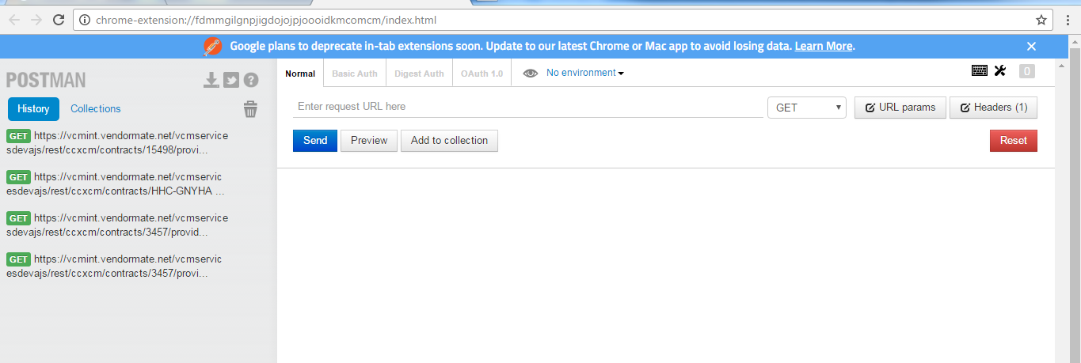

### Test restful service to get Payload

To test any rest service to fetch the payload , we need the get the request URL and pass the URL in url section of postman rest client. To get the URL perform below steps

### Get request URL

Login to the application using Firefox browser. Now the functionality which is to be called by rest service open that view in UI . For e.g in below example to get the distributor list of CCX contract a rest service is called.

Access the web page UI and turn on the debugger mode

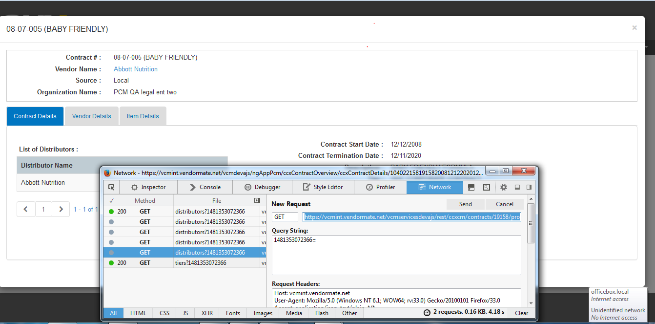

### Test the Service

* + - 1. Copy the URL from new request section of Network tab. URL will be retrieved in following format

**https://vcmint.vendormate.net/vcmservicesdevajs/rest/ccxcm/contracts/19158/provider/104022158/startDate/2008-12-12/endDate/2020-12-11/distributors?1481353072366**

* + - 1. Paste this URL in Post Man rest client and click on Send Button. We will get the payload

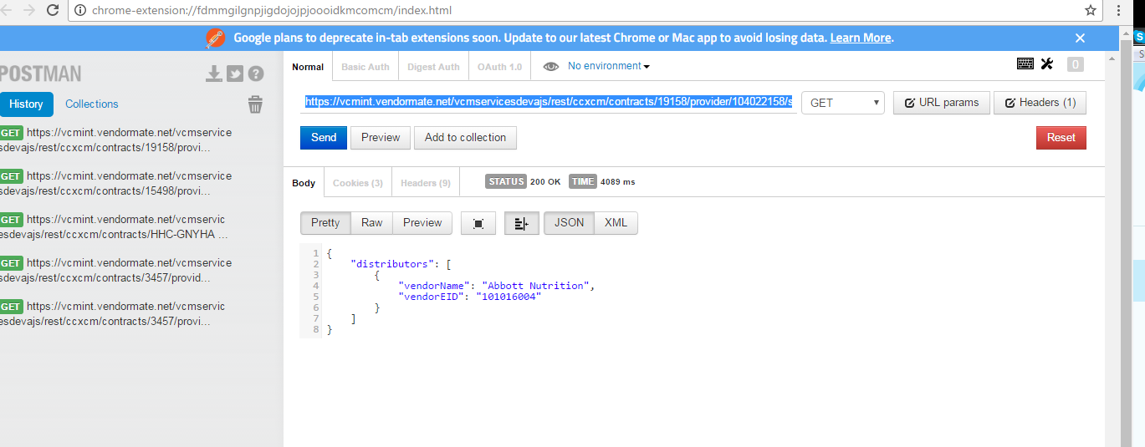

# Appendix

## References

https://www.getpostman.com/docs/